
Becoming A Person of Influence

Practical and Easy Principles to Apply to Everyday Life:
- Managers will see their employees respond with new enthusiasm
- Parents will connect with their children on a deeper level
- Coaches will see players blossom
- Pastors will reach more people
- Salespeople will break records
Whatever your vocation or aspiration, you can increase your impact on others by Becoming a Person of Influence. Learn simple, insightful ways to interact more positively with others, and watch your personal and organizational success go off the charts.

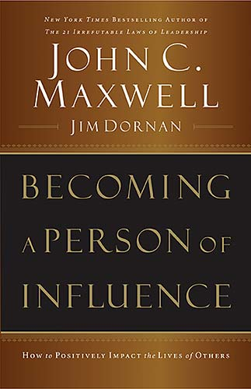

Yes! I would Like to Learn More about the
becoming a Person of Influence Program!!
Name
Email
Phone
Comment

